Hermes Airlines

**Hermes Airlines™** is the new fresh airlines company looking forward to become one of the best in it’s business. Owned by the young billionaire, sheikh **Abdul Hancock**, an enthusiast who wants to write his name on the airlines field history, Hermes™ is aiming the big sky.

The company will first go for poorly populated air routes, then planning to extend to the most crowded ones. The management system will be based on Divisional Organizational Structure, the experimented C.E.O. **Claus Bove** will lead a young team of professionals. On the promotion part, the marketing department is working hard on advertising campaigns, and also looking for some good sponsorship contracts with well-known sports clubs.

Really promising new airlines company, **Hermes™** is willing to soon compete with the big guys. Look up for **Hermes**, even the sky is reachable!

**Organizational Structure**

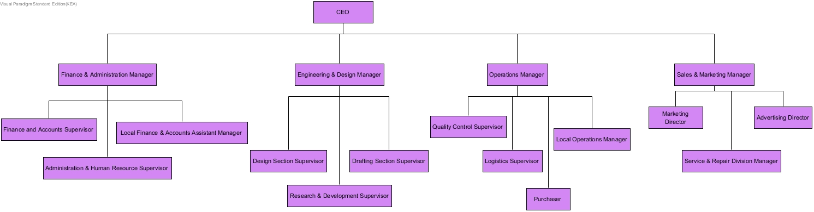As a suggestion for the **organizational structure**, our company will be based on a **divisional** structure type, in order to fit the requirements as we are willing to operate in a wide geographic area and have a larger scope as time goes. So we went for a C.E.O. as the main administrator in charge of managing the company, then we have managers for the different fields of operations, and finally supervisors and assistant managers for specific purposes and sub-fields. This way the workflow is divided efficiently among the employees and it can be controlled easier, improving the stability and maximizing the productivity of our business.

**SWOT Analysis**

Strengths – Weaknesses – Opportunities – Threats

Based on our company strategy, we analyzed these four entities in order to see if the company is will be worth the investment, which position will it occupy compared to the competitors and how can it be improved.

|  |  |
| --- | --- |
| **Strengths** | **Weaknesses** |
| * Little competition in our area of operation; * Low cost flights; * Lower running costs. | * Fewer customers due to our limited zone of operation; * We will be using fewer, smaller airports; * Indirect flights will be more common. |
| **Opportunites** | **Threats** |
| * It is possible to establish a partial local monopoly; * There is plenty of room for us to expand our operation area; * It is possible to expand our services. | * If more competition appears before we expand our company in a larger area the limited number of customers can make our company unprofitable; * If we are successful a larger company could attempt to push us out of business by coming up with a better offer than us(they could work at an unprofitable rate until we are out and then raise prices); * Bad marketing/lack of marketing can mean people do not know about the company; * Fluctuating oil prices. |

**Stakeholder Analysis**

Every entity around the company that can influence it in either good or bad way should be taken into account, because the better the knowledge we have about who and how can influence our company the better we can prepare for different situations that can occur. This way we can try to maximize the benefits that we gain and minimize the negative impacts as much as possible.

|  |  |  |  |  |
| --- | --- | --- | --- | --- |
| **Stakeholder** | **Importance** | **Influence and power** | **Interests/Positive impact** | **Concerns/Negative impacts** |
| **Abdul Hancock** | * Assure that everything is working financially | * Main investor/money source | * To recover investment * To provide flights in the local area | * Losing money * Not recovering investment * Bankruptcy for the company |
| **Partners/Suppliers** | * Allows the company to focus on its own area of expertise | * Provide materials and services that the airline company cannot provide for itself | * To sell their own products * Can provide discounts * Can facilitate development | * Rising prices * Disagreements between companies |
| **Customers** | * The life and blood of the company | * Power to influence would-be customers | * Can give positive reviews, make good publicity * Can become regular users, providing a more stable income to the company | * Can give negative reviews, make bad publicity * Can convince people to use different airlines |
| **Media** | * Makes the airline company more well known, for bad or for good | * Can help increase or decrease number of customers | * Can provide coverage for the company * Can attract more customers * Can be a platform for marketing | * Can provide negative coverage * Can turn customers away * Can make complaints more well known |
| **Regulatory authorities** | * Makes sure the airline respects all regulations | * A company needs their approval in order to function | * Can give a mark of approval/quality * Assures everything is safe and working order | * Can shut down an airline * Can turn customers away |
| **Competitors** | * Drive us to become better | * Are a comparison point for our own services | * Competition can provide novel ideas that we can use ourselves | * They steal our customers |
| **Internal staff** | * The engine of the company | * According to their work quality, they can influence the productivity | * Can positively influence the company income * Can positively impact customers | * Incompetent personnel can turn away customers * Unqualified staff can make a loss for the company |
| **The public** | * Potential customers | * No | * Public opinion can attract attention to the company | * Bad public opinion, rumors can discourage potential customers |

**Feasibility Study**

Here we evaluate the potential of our beloved company, if it can become profitable, helping with the final decision: should we proceed with this project or not. It is divided by the following categories:

**Operational feasibility**

???

**Technical feasibility**

???

**Schedule feasibility**

???

**Legal and contractual feasibility**

???

**Political feasibility**

???

**Economic feasibility**

???

**Risk analysis**

Risk is about the probability of something wrong to happen, and the negative consequences is implies. In order to be prepared for as much bad situations as possible, we organized the risks in a table based on the level of negative impact, the likelihood for them to happen, how to prevent them and so on. This is a good measure to be aware of what can go wrong along the project, and the possible solutions to solve these problems.

|  |  |  |  |  |  |  |
| --- | --- | --- | --- | --- | --- | --- |
| **Risk ID** | **Risk** | **Impact** | **Likelihood** | **Consequence** | **Solution** | **Preventive measurements** |
| 1 | Personnel risk  ->Morale is low due to a slow start<- | Medium | Medium | Employees are not efficient. | Organising motivational events. | Organising constant meetings to point out the evolution of the business. |
| 2 | Staffing levels  ->Product Development & Engineering are short staffed and can’t meet up the deadlines-< | Medium | Medium | The development of the business is delayed. | Hire more engineers | Get interns /students to help maintain the system. |
| 3 | Advertising risk  ->Bad advertising-< | Medium | High | The company is stuck in anonymity. | Advertise attractive offers (low profit) | Find innovative and creative ways of advertising the business. |
| 4 | Security risk  ->Missing security patches on web server hosting client info-< | High | Medium | The company loses clients’ trust. | Emergency update of all systems. | Being up to date with the new threats.(updated anti-virus) |
| 5 | Natural risk  ->Bad weather-< | Low | Medium | Flights get delayed and company loses clients. | Delayed flight compensation. | Being able to provide voucher for hotels and food for the waiting clients. |
| 6 | Failure to attract clients  ->Big players on the airline market put out better offers-< | High | Medium | Company goes bankrupt. | Invest more money in advertising. | Advertise attractive offers(low profit) |
| 7 | Terrorist attack | High | Low | Innocent people get hurt. Company property gets damaged. | Training our employees for this kind of situation | Working with secure airports |
| 8 | Economic crisis | Medium | Low | Less people can afford to travel.  Losing trust of investors. | Start restructuring the company. | A deposit account held at a bank or other financial institution that provides principal security. |